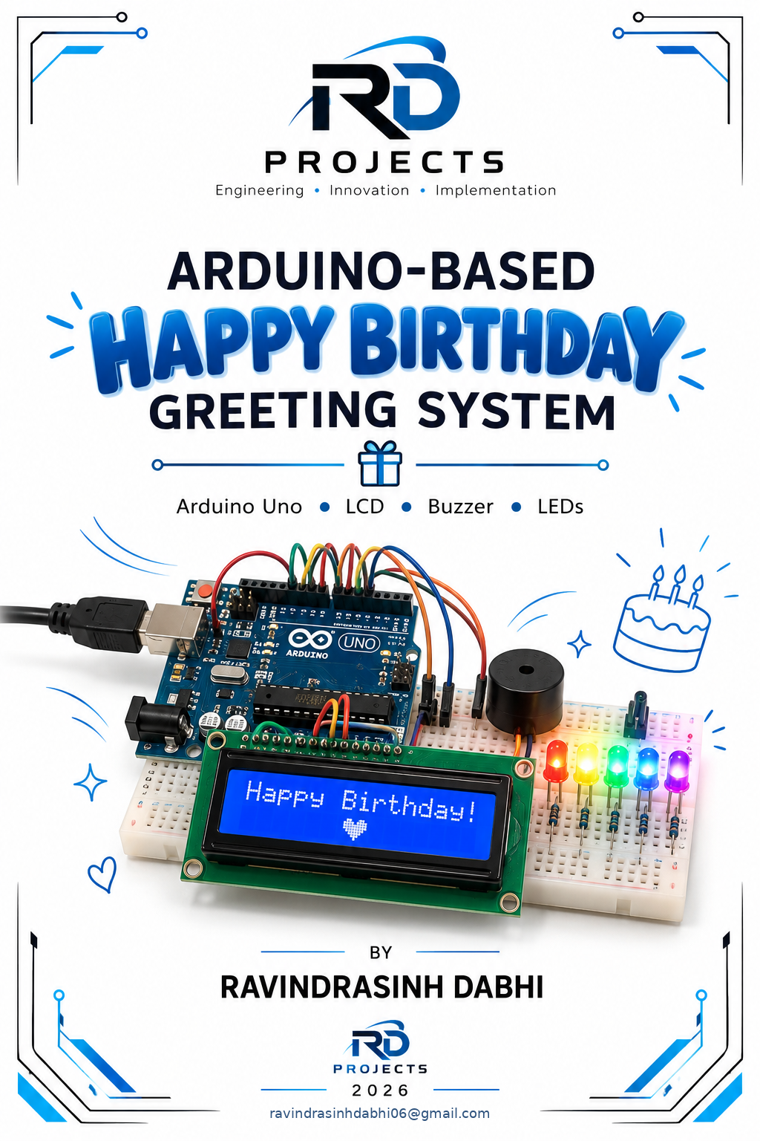

Abstract

The Happy Birthday Arduino Project is a simple embedded-system project developed using an Arduino Uno to create an interactive birthday greeting system. The main purpose of this project is to apply basic concepts of Arduino programming, digital input/output, LCD interfacing, buzzer control, and LED control in a practical project.
The system uses a 16×2 I2C LCD display to show a welcome message and a countdown before the birthday sequence begins. A buzzer is used to generate sound, while five LEDs are controlled by the Arduino to create a simple visual lighting effect during the birthday sequence. The project combines these hardware components with Arduino programming to produce a coordinated display, sound, and LED effect.
This project was developed as a self-learning and practical electronics project to improve understanding of microcontrollers, circuit connections, programming logic, and hardware-software integration. It demonstrates how a simple Arduino-based system can be designed to perform a specific interactive task using commonly available electronic components.

Table of Contents

List of Figures IV
Chapter – 1 : INTRODUCTION 1
Chapter – 2 : OBJECTIVE 2
Chapter – 3 : COMPONENTS USED 3
3.1 Arduino Uno 3
3.2 16×2 I2C LCD 3
3.3 Buzzer 4
3.4 LEDs 4
3.5 Breadboard and Jumper Wires 4
3.6 Resistors 5
Chapter – 4 : Block Diagram 6
4.1 Block Diagram Representation 6

List of Figures
Figure 1 Arduino Uno with Cable 3
Figure 2 16*2 LCD 3
Figure 3 Buzzer 4
Figure 4 Coloring LED 4
Figure 5 Breadboard and Jumper Wires 5
Figure 6 Resistors 5

Chapter – 1 : INTRODUCTION

Arduino-based embedded systems provide a simple and effective way to understand the interaction between hardware and software. A microcontroller can receive instructions from a program and control different electronic components such as LEDs, buzzers, displays, sensors, motors, and relays. Working with Arduino therefore helps in developing practical knowledge of programming, circuit design, troubleshooting, and hardware interfacing.
The Happy Birthday Arduino Project is a simple interactive electronic system developed using an Arduino Uno. The system combines a 16×2 I2C LCD display, buzzer, and five LEDs to create a programmed birthday greeting. The LCD displays messages and a countdown, the buzzer generates sound, and the LEDs produce a visual lighting effect during the birthday sequence.
The project includes a 10-second countdown, after which the Arduino executes the programmed birthday sequence. All the connected components are controlled according to the logic written in the Arduino program. This makes the project a practical example of digital output control, timing, LCD interfacing, and sequential programming.
One of the main advantages of developing this type of project is that it provides practical experience with commonly used electronic components at a relatively low cost. It also helps in understanding how different output devices can be controlled simultaneously by a single microcontroller. The project can be modified easily by changing the program, adding more LEDs, changing the displayed messages, or integrating additional sensors and modules.
This project was developed as a self-learning project to improve practical knowledge of Arduino programming, electronic circuit connections, LCD interfacing, LED control, buzzer control, timing functions, and hardware-software integration. The experience gained from this project can be used as a foundation for developing more advanced automation, embedded-system, IoT, and control-system projects.

Chapter – 2 : OBJECTIVE

The main objectives of the Happy Birthday Arduino Project are:
- To understand the basic working and programming of the Arduino Uno microcontroller.
- To learn how to interface a 16×2 I2C LCD display with Arduino.
- To control multiple LEDs using Arduino digital output pins.
- To interface and control a buzzer for generating sound.
- To implement a 10-second countdown using Arduino programming.
- To understand the use of timing and delay functions in an embedded system.
- To combine multiple output devices and operate them according to a predefined program sequence.
- To improve practical knowledge of electronic circuit connections and hardware interfacing.
- To develop troubleshooting and debugging skills while building and testing the circuit.
- To gain hands-on experience in integrating hardware and software to create a functional embedded-system project.
- To build a basic foundation for developing more advanced Arduino, automation, and embedded-system projects in the future.

Chapter – 3 : COMPONENTS USED

3.1 Arduino Uno
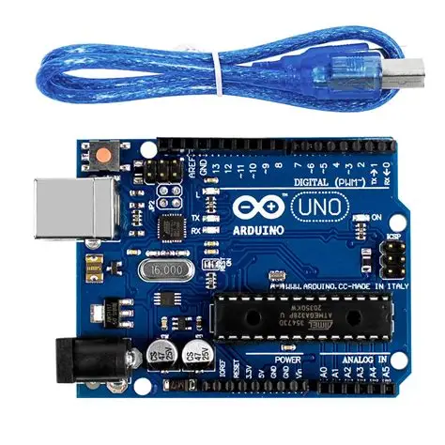
The Arduino Uno is the main control unit of the project. It is based on the ATmega328P microcontroller and executes the program uploaded through the Arduino IDE. The digital output pins are used to control the LEDs and buzzer, while the I2C communication pins are used to interface with the LCD.

Figure 1 Arduino Uno with Cable

3.2 16×2 I2C LCD
The 16×2 LCD is used to display text and numerical information. It can display 16 characters in each of two rows. The I2C module reduces the number of Arduino pins required for communication, making the circuit simpler.
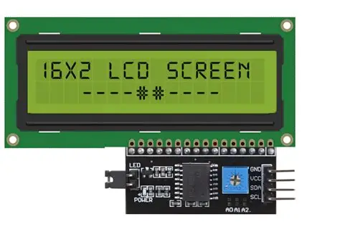

Figure 2 16*2 LCD

3.3 Buzzer
The buzzer is used to generate an audible sound during the programmed sequence. It is controlled by an Arduino digital output pin and can be switched ON and OFF according to the program.
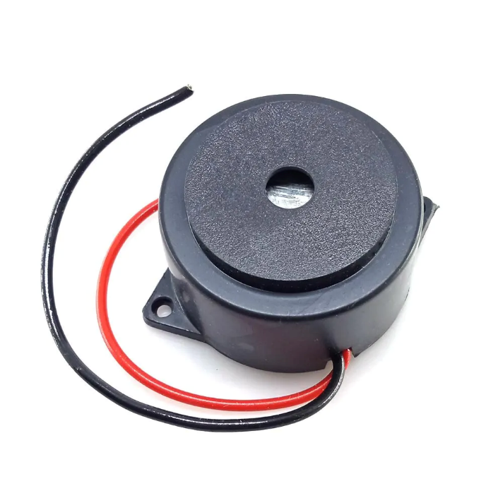

Figure 3 Buzzer

3.4 LEDs
Five LEDs are used to create a visual lighting effect. Each LED is connected to a separate Arduino digital output pin, allowing the Arduino to control their ON/OFF sequence through the program.
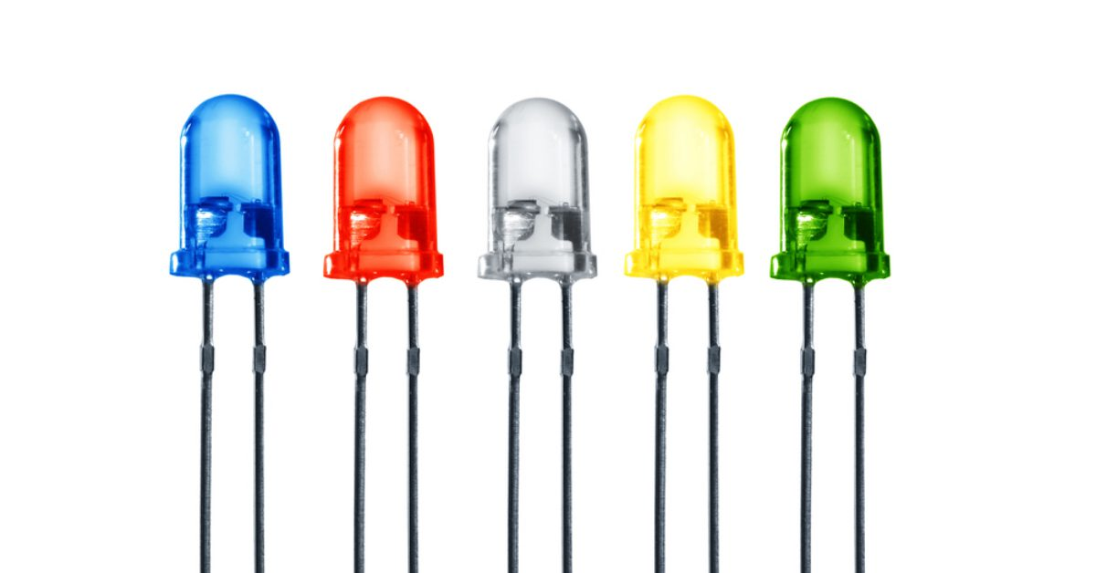

Figure 4 Coloring LED

3.5 Breadboard and Jumper Wires
The breadboard is used to assemble the circuit without permanent soldering. Jumper wires are used to establish electrical connections between the Arduino, LCD, LEDs, buzzer, and power supply.
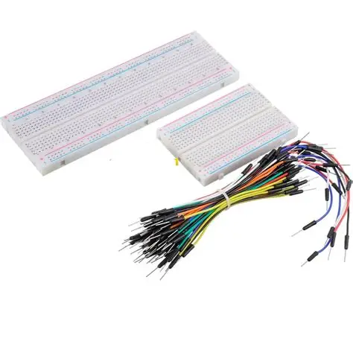

Figure 5 Breadboard and Jumper Wires

3.6 Resistors
Resistors are connected in series with the LEDs to limit the current flowing through them and protect the LEDs from excessive current.
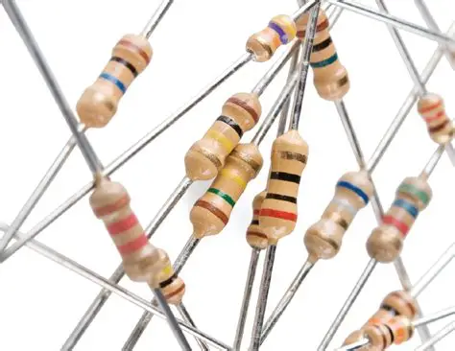

Figure 6 Resistors

Chapter – 4 : Block Diagram and Circuit Diagram

4.1 Block Diagram Representation
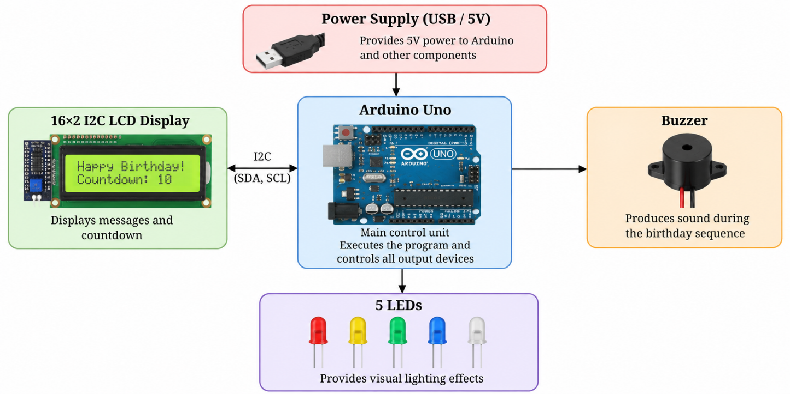
The block diagram represents the basic flow of the Happy Birthday Arduino Project. The Arduino Uno acts as the central control unit. It receives the programmed instructions and controls the LCD display, buzzer, and LEDs according to the required sequence.
Figure 7 HBD Block Diagram

- Power Supply: Provides the required electrical power to the Arduino and connected components.
- Arduino Uno: Acts as the main controller and executes the programmed instructions.
- 16×2 I2C LCD: Displays the welcome message, countdown, and other programmed messages.
- Buzzer: Produces an audible sound as part of the birthday sequence.
- Five LEDs: Produce visual lighting effects according to the programmed sequence.
The Arduino controls all three output sections according to the program. The coordination of the LCD, buzzer, and LEDs produces the final interactive birthday greeting.

4.2 Circuit Diagram
The circuit diagram of the Happy Birthday Arduino Project shows the electrical connections between the Arduino Uno, 16×2 I2C LCD, buzzer, and five LEDs. The Arduino Uno works as the main control unit and provides the required control signals to the connected output devices.
The 16×2 LCD with I2C module is connected to the Arduino through the I2C communication interface. The LCD uses the SDA and SCL lines for communication, reducing the number of digital pins required for display control.
The buzzer is connected to a digital output pin of the Arduino and is controlled through the program to generate the required sound. The five LEDs are connected to separate digital output pins. Suitable current-limiting resistors are used with the LEDs to protect them from excessive current.
The complete circuit can be assembled on a breadboard, which makes the connections easy to modify and troubleshoot during development and testing.
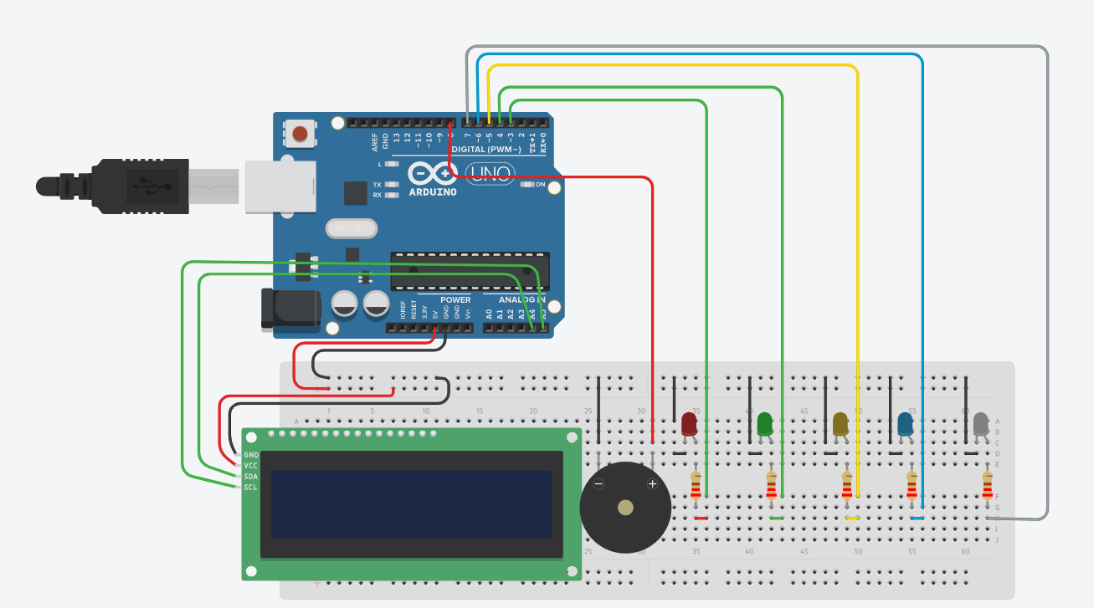
Figure 8 Circuit Diagram
Jumper wires are used to make electrical connections between the Arduino Uno and other components mounted on the breadboard. They provide connections for power, ground, control signals, and I2C communication.

Chapter – 5 Hardware Implementation
The hardware implementation of the Happy Birthday Arduino Project involves assembling and connecting all the required electronic components on a breadboard. The Arduino Uno is used as the main control unit, while the 16×2 I2C LCD, buzzer, and five LEDs are connected to the Arduino through jumper wires.
The project was first assembled on a breadboard to make the circuit easy to modify and troubleshoot. The Arduino Uno was placed as the central controller, and the required power and ground connections were established. The LCD was connected using the I2C interface, while the buzzer and LEDs were connected to the assigned digital output pins.

5.1 Hardware Assembly
The hardware was assembled in the following sequence:
- The Arduino Uno was used as the main control unit of the project.
- The 16×2 I2C LCD was connected to the Arduino through the SDA and SCL lines.
- The buzzer was connected to its assigned digital output pin and ground.
- Five LEDs were connected to separate digital output pins through suitable current-limiting resistors.
- Jumper wires were used to establish the required signal, power, and ground connections.
- All components were checked for correct polarity and proper electrical connections before powering the circuit.
- The Arduino program was uploaded and the operation of each component was tested.
- After individual testing, all components were operated together to verify the complete birthday sequence.

5.2 Testing and Verification
After completing the physical assembly, the project was tested step by step. First, the LCD was checked to verify that the programmed messages could be displayed correctly. The LEDs were then tested individually to confirm their operation. The buzzer was also tested to ensure that it produced the required sound.
Finally, the complete system was tested together. The Arduino started the programmed sequence, displayed the countdown on the LCD, and then controlled the LEDs and buzzer according to the programmed logic.
//program used to testing LCD
#include <LiquidCrystal_I2C.h>
LiquidCrystal_I2C lcd(0x27,16,2);
void setup()
{
lcd.init();
lcd.backlight();
}
void loop()
{
lcd.clear();
lcd.setCursor(0, 0);
lcd.print("Hello world!");
delay(3000);
lcd.clear();
lcd.setCursor(0,0);
lcd.print("happy birthday");
delay(3000);
}
All the programs are available in git hub profile

5.3 Final Hardware Setup
The final hardware setup provides a compact and simple demonstration of microcontroller-based control and hardware-software integration. The breadboard-based arrangement also makes it convenient to inspect connections, identify wiring problems, and make modifications during the development process.
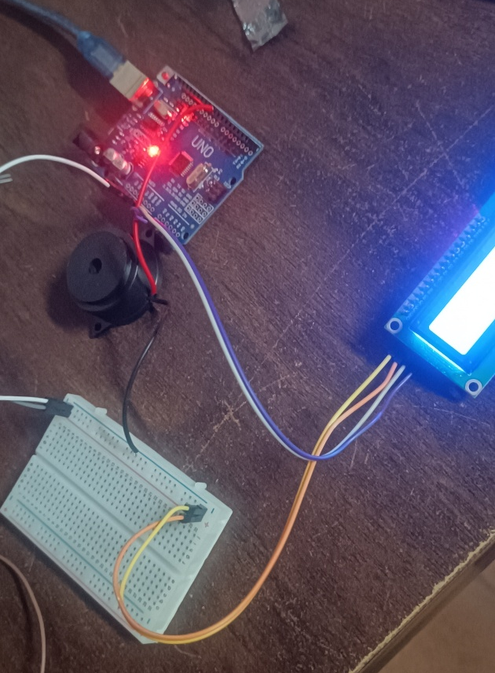

Figure 9 Buzzer Checking

5.4 Working
The Happy Birthday Arduino Project starts operating when the Arduino Uno is powered through the USB cable or a suitable power supply. After power-up, the Arduino initializes the LCD, buzzer, and five LEDs according to the program.
First, the 16×2 I2C LCD displays the initial message programmed in the Arduino. The system then starts a 10-second countdown on the LCD. During this period, the Arduino updates the countdown value at regular time intervals.
After the countdown reaches zero, the main birthday sequence starts. The LCD displays the programmed birthday message, while the five LEDs operate in a predefined sequence to create a visual lighting effect. At the same time, the buzzer produces sound according to the programmed timing.
The Arduino controls the complete sequence automatically. The timing, order of LED operation, LCD messages, and buzzer operation are determined by the Arduino program. Once the sequence is completed, the system remains in the programmed final state until it is restarted or the program is executed again.

5.5 Sequence of Operation

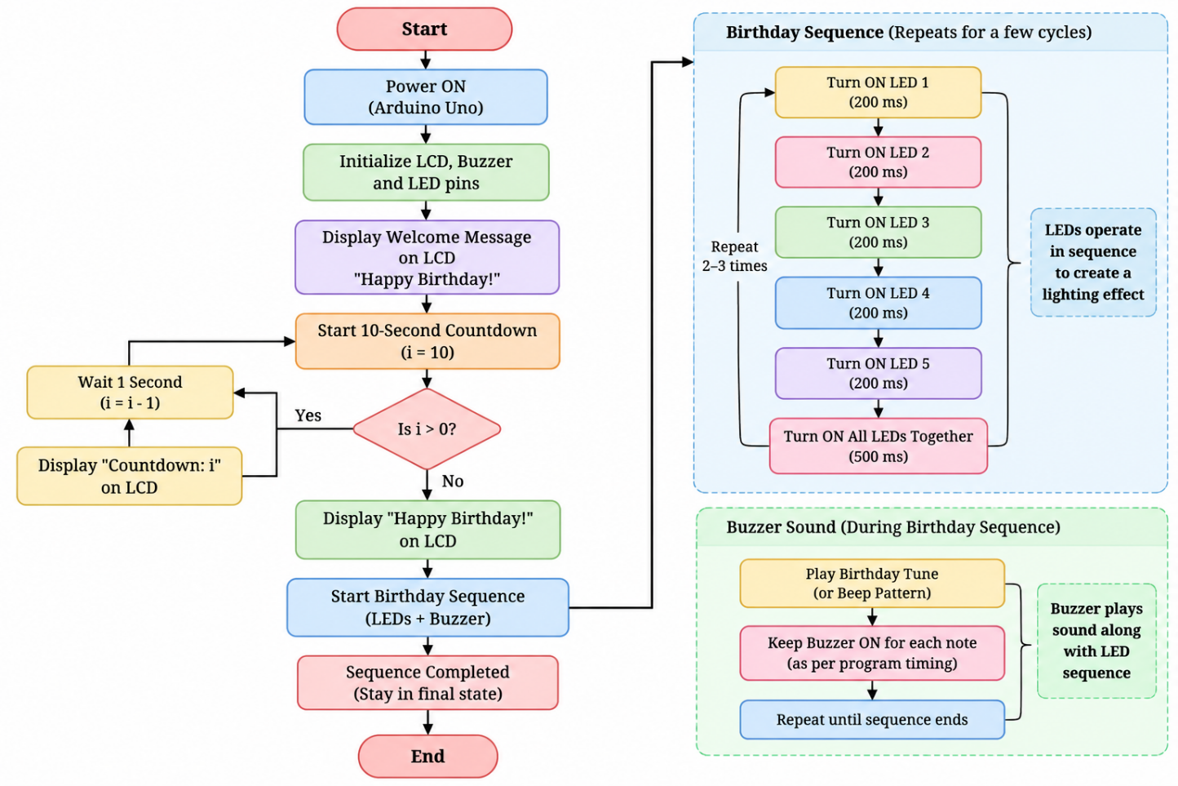
Figure 10 Sequence

- The Arduino starts the system and initializes the LCD, LEDs, and buzzer.
- The LCD displays “Happy Birthday!” and starts a 10-second countdown.
- After the countdown reaches zero, the birthday sequence begins.
- The five LEDs turn ON in a sequential pattern to create a lighting effect.
- The buzzer produces the birthday tune/sound along with the LED sequence.
- The LED and buzzer sequence repeats for the programmed number of cycles.
- After completion, the system reaches the final state.

5.6 Arduino Program
// this is the complete code of the mini project 1
// other code are made for the testing and understanding purpose
// but here some extra things are things i can't make code which understand only in one code like for loop
#include <LiquidCrystal_I2C.h>
LiquidCrystal_I2C lcd(0x27, 16, 2);

// Buzzer
int buzzer = 8;
// LEDs
int led1 = 9;
int led2 = 10;
int led3 = 11;
int led4 = 12;
int led5 = 13;
// Birthday melody
int melody[] = {
262, 262, 294, 262, 349, 330,
262, 262, 294, 262, 392, 349,
262, 262, 523, 440, 349, 330, 294,
466, 466, 440, 349, 392, 349
};
// Note duration
int duration[] = {
300, 300, 600, 600, 600, 1200,
300, 300, 600, 600, 600, 1200,
300, 300, 600, 600, 600, 600, 1200,
300, 300, 600, 600, 600, 1200
};
int numberOfNotes = 26;
void setup()
{
lcd.init();
lcd.backlight();

pinMode(buzzer, OUTPUT);
pinMode(led1, OUTPUT);
pinMode(led2, OUTPUT);
pinMode(led3, OUTPUT);
pinMode(led4, OUTPUT);
pinMode(led5, OUTPUT);
}
void loop()
{
// Turn all LEDs OFF
digitalWrite(led1, LOW);
digitalWrite(led2, LOW);
digitalWrite(led3, LOW);
digitalWrite(led4, LOW);
digitalWrite(led5, LOW);
// INTRODUCTION
lcd.clear();
lcd.setCursor(0, 0);
lcd.print("It's me");
lcd.setCursor(0, 1);
lcd.print("Ravi");
delay(2000);
lcd.clear();
lcd.setCursor(0, 0);
lcd.print("Are you ready?");
delay(2000);
// 10 SECOND COUNTDOWN
for (int count = 10; count >= 1; count--)
{
lcd.clear();
lcd.setCursor(0, 0);
lcd.print("Get Ready!");
lcd.setCursor(7, 1);
lcd.print(count);
tone(buzzer, 1000);
delay(200);
noTone(buzzer);
delay(800);
}
// HAPPY BIRTHDAY
lcd.clear();
lcd.setCursor(0, 0);
lcd.print("Happy Birthday!");
lcd.setCursor(0, 1);
lcd.print("Ravi!");
for (int i = 0; i < numberOfNotes; i++)
{
tone(buzzer, melody[i]);
// LED 1
if (i % 5 == 0)
{
digitalWrite(led1, HIGH);
digitalWrite(led2, LOW);
digitalWrite(led3, LOW);
digitalWrite(led4, LOW);
digitalWrite(led5, LOW);
}
// LED 2
else if (i % 5 == 1)
{
digitalWrite(led1, LOW);
digitalWrite(led2, HIGH);
digitalWrite(led3, LOW);
digitalWrite(led4, LOW);
digitalWrite(led5, LOW);
}
// LED 3
else if (i % 5 == 2)
{
digitalWrite(led1, LOW);
digitalWrite(led2, LOW);
digitalWrite(led3, HIGH);
digitalWrite(led4, LOW);
digitalWrite(led5, LOW);
}
// LED 4
else if (i % 5 == 3)
{
digitalWrite(led1, LOW);
digitalWrite(led2, LOW);
digitalWrite(led3, LOW);
digitalWrite(led4, HIGH);
digitalWrite(led5, LOW);
}
// LED 5
else
{
digitalWrite(led1, LOW);
digitalWrite(led2, LOW);
digitalWrite(led3, LOW);
digitalWrite(led4, LOW);
digitalWrite(led5, HIGH);
}
delay(duration[i]);
noTone(buzzer);
delay(80);
}
digitalWrite(led1, LOW);
digitalWrite(led2, LOW);
digitalWrite(led3, LOW);
digitalWrite(led4, LOW);
digitalWrite(led5, LOW);
delay(1000);
lcd.clear();
lcd.setCursor(0, 0);
lcd.print("Have a Great");
lcd.setCursor(0, 1);
lcd.print("Day!");
delay(3000);
lcd.clear();
lcd.setCursor(0, 0);
lcd.print("Enjoy Your Day!");

delay(3000);
}

Chapter – 5 Project Output
The completed Happy Birthday Arduino Project successfully performs the programmed birthday sequence using the LCD, buzzer, and five LEDs.
The observed outputs of the project are:
- The 16×2 LCD displays the programmed welcome message and 10-second countdown.
- After the countdown, the LCD displays the birthday message.
- The five LEDs operate in the programmed sequence to produce a visual effect.
- The buzzer produces the programmed birthday sound/tune.
- All outputs operate automatically according to the Arduino program.

